Local Search, Linking Lexica

Introduction
This document describes the effort to link a number of existing lexica. In order to do that, two steps are to be taken. First, all descriptive elements of the lexica have to be harmonized. This has been done by converting the lexica to RDF and using standard vocabularies for the labeling of the content. The second step of linking data would involve making direct links between the content elements or lemma’s of the lexica. This report describes the first step. In the sections below we will present the selection of vocabularies that we have used in our effort, give a description of the legacy lexica that have been used, the method that has been used to make the conversion and, finally, an outlook on what will be required to directly link the content of the lexica.

Data model, standards
A number of vocabularies like “Lexinfo” and “Ontolex” pertaining to lexica have emerged in recent years that have gathered quite some following. Although they are still in development we will use these among others. The general set of vocabularies that we have used is:
@prefix rdf: <http://www.w3.org/1999/02/22-rdf-syntax-ns#> .
@prefix rdfs: <http://www.w3.org/2000/01/rdf-schema#> .
@prefix synsem <http://www.w3.org/ns/lemon/synsem#> .
@prefix lexinfo: <http://www.lexinfo.net/ontology/2.0/lexinfo#> .
@prefix intskos: <http://rdf.ivdnt.org/schema/lexica#> .
@prefix ontolex: <http://www.w3.org/ns/lemon/ontolex#> .
The intskos vocabulary has been introduced to collect and define all terms that could not be located in one of the other vocabularies.

Data sets

CELEX
The CELEX database has been published first in 1990. It contained extensive descriptions of word forms and lemma’s of three languages: Dutch, English and German. It has been a major lexical source for many years. The data is distributed through a number of agencies, like ELRA. Moreover, it was accessible through a web interface hosted at the Max Planck Institute for Psycholinguistics. In 2001 the CELEX-Project was halted because of financial reasons. In 2015 the web interface was transferred to the “Instituut voor de Nederlandse Taal”. The data was cleansed to some extent. That version of the data has been the basis for the present work.
The main elements of the CELEX lexicon are lemma’s and word forms. The word forms are linked to the corresponding lemma’s.
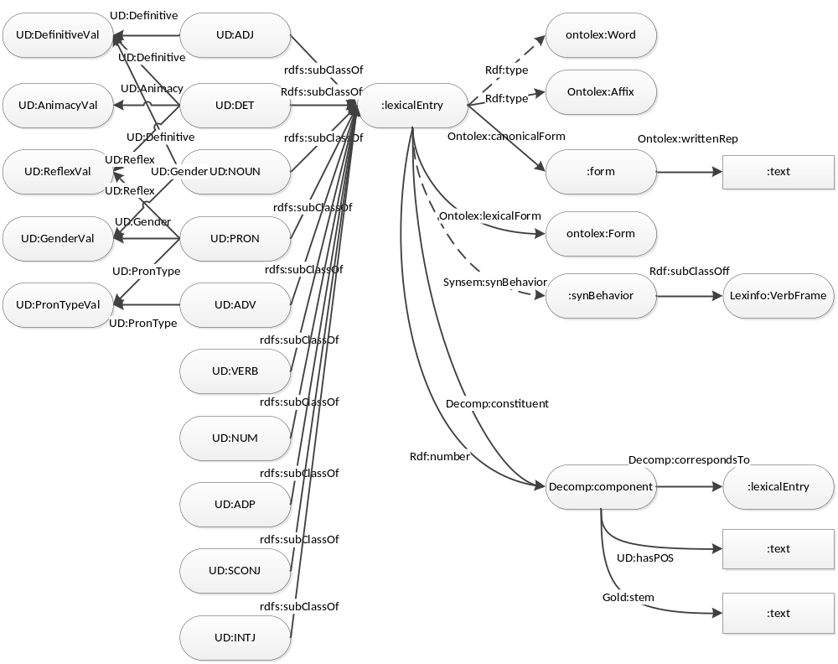
Figure 1. CELEX Lemma’s
Figure 1 expresses the data structure of the lemma’s represented in RDF. Lemma’s are defined as lexical entries that have a number of properties (obligatory=solid, optional=dashed) . Moreover, these LE’s are linked to a number of word forms.
The word forms (see Figure 2) have a relatively flat structure with obligatory an orthographic and phonetic representation and a number of optional morphological and grammatical parameters.
The original CELEX data contained several phonetic transcriptions in ASCII. These have been collapsed into one IPA (Unicode) transcription. Furthermore, the original data also contains several alternative spelling forms which are not standard (e.g. ‘eksamen’ for the official ‘examen’). These have been discarded.
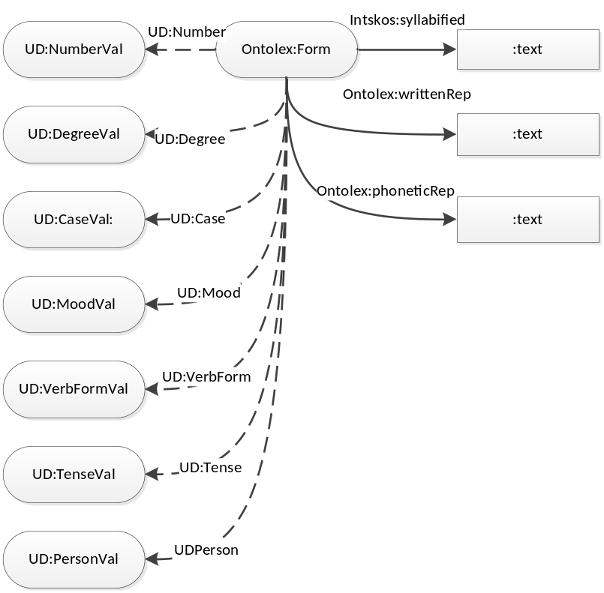
Figure 2: CELEX Word Forms
Since the CELEX lexicon has been built almost 30 years ago, it has become somewhat dated. Nonetheless it is still a valuable source of information since it is very rich. Many features have not been added to the conversion as yet.

Morphology.
CELEX contains a rich morphological analysis of the lemma’s. Word forms are not analyzed apart from a specification of the type of inflection. The lemmas contain tree-structured morphological analyses like the following:
Aanbevelenswaardig: (((aan)[P],(beveel)[V])[V],(s)[A|V.A],((waarde)[N],(ig)[A|N.])[A])[A]
The word forms in this analyses are not linked to the corresponding entries in the lexicon. These links have to be established in order to make a useful linked lexical resource. That means that the analysis above needs to be linked to the lemma’s “aanbevelen” and “waardig” and the affix “s”. These lemma’s then need to be further decomposed and linked to resp. “aan”, “bevelen” and “waarde”, “-ig” (affix). The components in the morphological analyses reference entries by their stem and the word class. In our conversion we will provide links from compounds to lexical entries in cases where the match is unambiguous. In case of ambiguity we only provide the two available properties; stem and word class.
Affixes were not part of the original lexicon, but were added these as LexicalEntries to the converted lexicon in order to preserve as much as possible of the original morphological analysis.
Some words in CELEX have multiple analyses. We convert all these analyses.
The CELEX morphological analysis provides implicit information on the order of the compounds. In the conversion the order of the constituents is made explicit by adding an ordering relation between Lexical entry and component using rdf numbering (rdf:_1, rdf:_2, etc.) according to the Ontolex specification.
The following example illustrates the double relation (constituent, number) between lexical entry and component:
:celex_lemma_47843
decomp:constituent :celex_comp_92553;
rdf:_1 :celex_comp_92553;
decomp:constituent :celex_comp_92554;
rdf:_2 :celex_comp_92554;
decomp:constituent :celex_comp_92555;
rdf:_3 :celex_comp_92555 .

Possible additions
The data set could be expanded in the following way:
- Adding syntactic features like complementation patterns.
- Adding semantic and ontological features.

CGNLEX
The CGN Lexicon has been developed as a companion of the Spoken Dutch Corpus (Corpus Gesproken Nederlands – CGN) and comprises almost all word forms that occur in the corpus. The lexicon only includes words that occur in the corpus and excludes those types for which extensive lexical information is irrelevant. The latter applies to non-words, incomplete words, foreign words, punctuation marks, and inaudible or incomprehensible words. The lexicon is accompanied by a (small) lexicon of multi-word expressions, that consists mainly of (multi part) proper names and separable verbs. This MWE lexicon has not (yet) been included in the conversion. The design of CGNLEX has borrowed much of CELEX, therefore the rdf data model (Figure 3) resembles that of CELEX (Figure 1). Note that the layer with word types has been omitted in the below diagram.
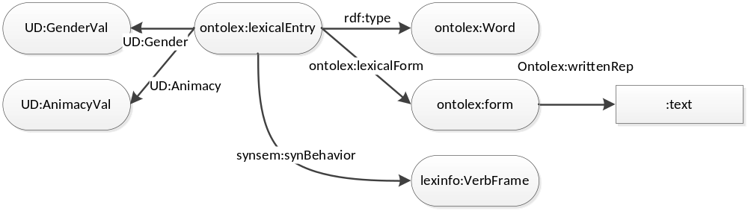
Figure 3: CGNLEX Lemma's
The data model for the word forms (Figure 4) also resembles that of CELEX (Figure 2), but CGNLEX has a few additional properties. Since CGNLEX is primarily a word form lexicon, these have been specified for the word forms. First, CGNLEX has an additional definition for some words. We have used the standard SKOS vocabulary to model that property. Further, CGNLEX phonetic forms also contains markers for usage and region. For these we have used the MADS/RDF skos in order to indicate the Flemish language variety. Lexinfo provided the possibility to specify the formal and informal register. So, the additional vocabularies for CGNLEX are:
@prefix madsrdf: <http://www.loc.gov/mads/rdf/v1#> .
@prefix skos: <http://www.w3.org/2004/02/skos/core#> .

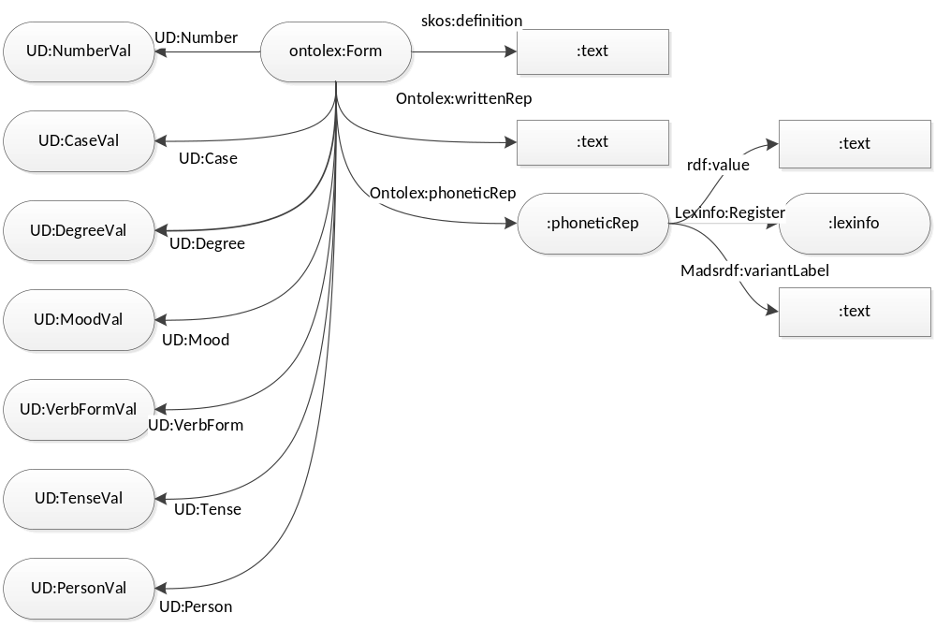
Figure 4: CGNLEX word forms
There are a number of things that can be done to improve the quality of this data set;
- As previously mentioned, adding the multi-word lexicon
- Transfer the properties that pertain to the whole paradigm from the word level to the lemma level.
- Align CGNLEX with CELEX

DUELME
DuELME (Dutch Electronic Lexicon of Multiword Expressions) is one of the results of the project “Identification and Representation of Multiword Expressions” (IRME) and contains lexical descriptions of over 5,000 multiword expressions (MWEs). The lexical descriptions boast to be highly theory- and implementation-neutral. The lexicon is primarily intended for the use in various NLP systems. The lexicon has been converted to LMF in a follow-up project within the CLARIN-NL programme and has been made available by the TST-Centrale in that form. Moreover, the lexicon can be accessed through a web interface. The LMF version is also the basis for the present conversion into rdf.
For modelling the rdf version we used the special vocabulary for LMF provided by Infolex. DUELME also provides a corpus of citations from newspapers illustrating the use of the MWE’s. We included these as attestations in the model, using the “prov“ vocabulary and “dcterms” to specify the sources. These are the vocabularies added to the model:
@prefix lmf: <http://www.lexinfo.net/lmf> .
@prefix prov: <http://www.w3.org/ns/prov#> .
@prefix dcterms: <http://purl.org/dc/terms/> .
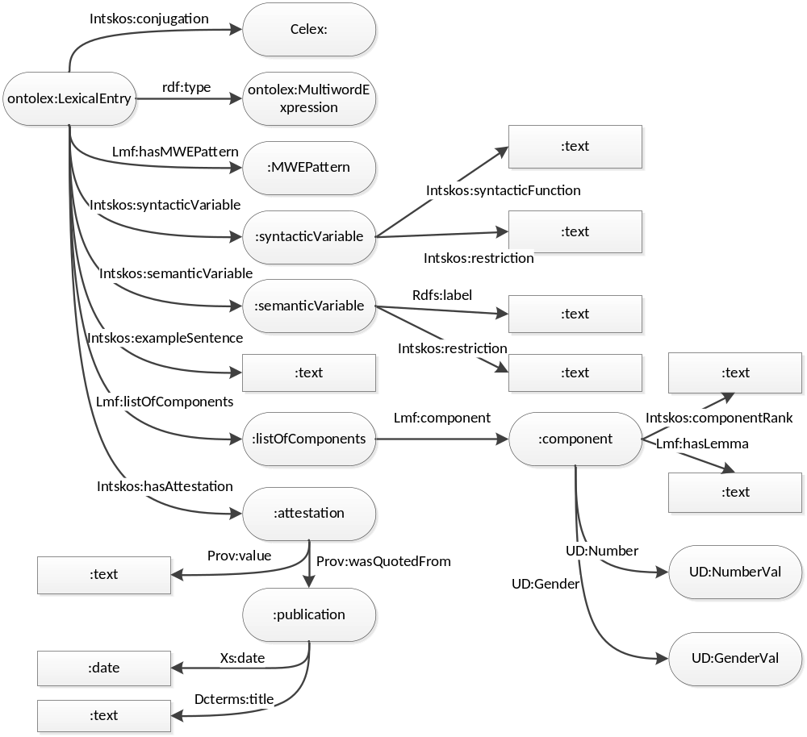
Figuur 1: DUELME
In the previous figure the lexical entries point to a MWEPattern. The model for these patterns is given below
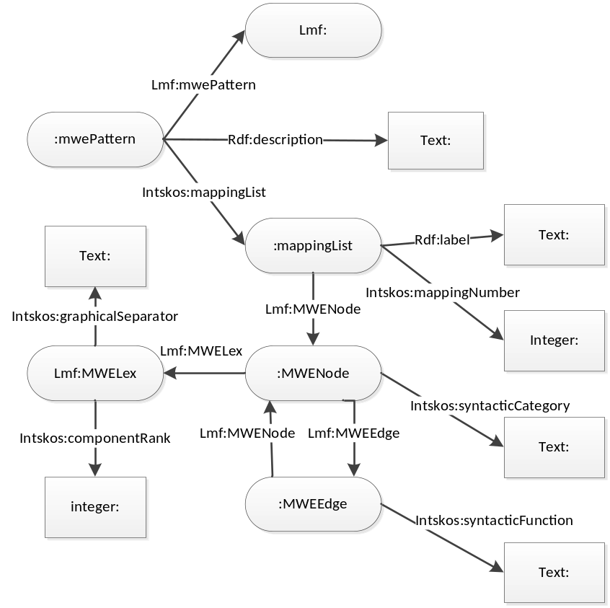
Figuur 2: DUELME MWEPatterns
The grammatical constraints of MWE’s are expressed in generalized MWEPatterns. The components of the MWE correspond in order with numbered slots in the MWEPattern as is shown in the fragments below.
<LexicalEntry conjugation="H" expression="rol spelen" patternID="ec133" type="unspecified">
<ListOfComponents>
<Component nCount="count" nGen="de" nNum="sg">
<Lemma writtenForm="rol"/>
</Component>
<Component>
<Lemma writtenForm="spelen"/>
</Component>
</ListOfComponents>

<MwePattern ID="ec133" description="Expressions headed by a verb, taking a direct object consisting of a modifiable noun.">
<MweNode syntacticCategory="VP">
<MweEdge syntacticFunction="su">
<MweNode/>
</MweEdge>
<MweEdge syntacticFunction="obj1">
<MweNode syntacticCategory="NP">
<MweEdge syntacticFunction="hd">
<MweNode syntacticCategory="N1">
<MweLex componentRank="1" graphicalSeparator="space"/>
</MweNode>
</MweEdge>
</MweNode>
</MweEdge>
<MweEdge syntacticFunction="hd">
<MweNode syntacticCategory="V">
<MweLex componentRank="2" graphicalSeparator="space"/>
</MweNode>
</MweEdge>
</MweNode>

In order to facilitate search for a certain MWE in treebanks, we have augmented the MWE’s with a partial tree structure derived from the corresponding MWEPattern with the word slots filled in as is shown in the example below.
<LexicalEntry conjugation="H" expression="rol spelen" patternID="ec133" type="unspecified">
[…]
<MweNode syntacticCategory="VP">
<MweEdge syntacticFunction="su">
<MweNode/>
</MweEdge>
<MweEdge syntacticFunction="obj1">
<MweNode syntacticCategory="NP">
<MweEdge syntacticFunction="hd">
<MweNode syntacticCategory="N1">
<MweLex componentRank="1"
graphicalSeparator="space"
nCount="count"
nGen="de"
nNum="sg">
<Lemma writtenForm="rol"/>
</MweLex>
</MweNode>
</MweEdge>
</MweNode>
</MweEdge>
<MweEdge syntacticFunction="hd">
<MweNode syntacticCategory="V">
<MweLex componentRank="2"
graphicalSeparator="space">
<Lemma writtenForm="spelen"/>
</MweLex>
</MweNode>
</MweEdge>
</MweNode>
</LexicalEntry>

With the above partial tree structure rendered in rdf, users can use that description to search tree banks for sentences using these mwe’s (provided that the LMF notation can be mapped onto a standard tree mapping like UD).
There are many loose end in the data as it is described above. Below we will present some of the shortcomings and possible solutions.
- The component element refers to a string representing the lemma. It would be better if would point to a lexical entry in some external dataset like CELEX, or OpenDutchWordnet.
- The description of MWEPatterns presents a number of constraints on the mapping of components on word forms. These should be more formalized.

http://catalog.elra.info/product_info.php?products_id=439
http://celex.mpi.nl/
https://portal.clarin.inl.nl/webcelex/
http://tst-centrale.org/images/stories/producten/documentatie/duelme_documentatie_en.pdf
http://tst-centrale.org/nl/tst-materialen/lexica/duelme-detail
http://duelme.clarin.inl.nl/

